# Story W13. Log in

As a user   
I want to log in  
so that I am known to the application.

## Wireframes:

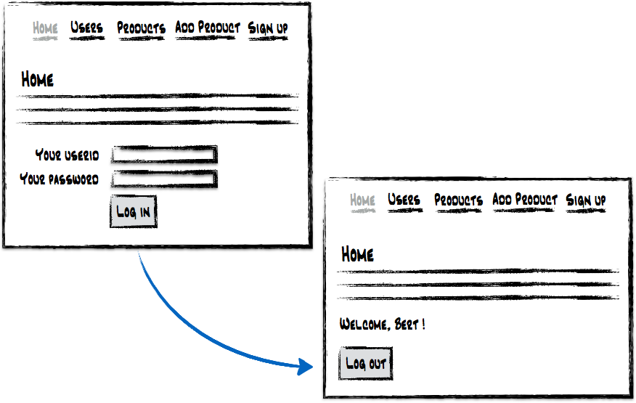

## Workflow:

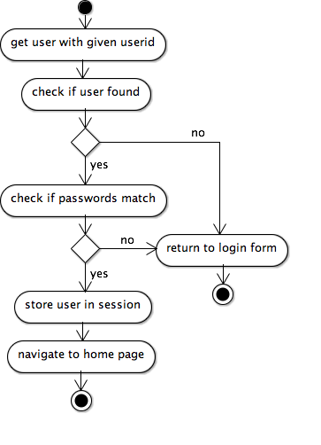

## Technical details

1. Check if you still can run the test RegisterTest succesfully.
2. In lab 4 (story W11) you have added following method to Person:

* A method *isPasswordCorrect (password:String)* which returns true if the given password matches with the hashed password saved to that person.

Add following method to ShopService:

* A method *getUserIfAuthenticated(userid:String, password:String)* which returns the person if he was found on the database (given a userid) and if the passwords match. Else, the method should return null.
* You can run ShopServiceTest.java to verify if your code works as it should.

Add to Servlet:

* A method *login()* that reads the userid and password and calls the *getUserIfAuthenticated ()* method on the service. Add the user to the session if login was successful.

1. You can use the jstl tag <c:choose> to decide if you want to show a button or not…

Remark: When a sequence of the database generates the userid, you need to choose another parameter to identify the user, e.g. the e-mail address.

## Acceptance criteria:

* When a user is not logged in, and wants to navigate to the web site, a login form is shown on the home page.
* On the login form, users can enter their userid (e-mail) and password.
* If a person logs in correctly, the user is redirected to the home page that now shows the text “*Welcome <FirstName>!”* and a button “*Log Out*” (no login form).
* If login failed, an error message is shown on the login form “*No valid userid/password*”.
* The userid is not case sensitive.